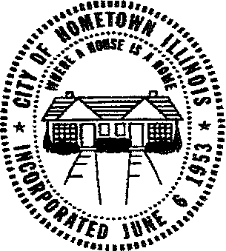

CITY OF HOMETOWN
4331 SOUTHWEST HIGHWAY
HOMETOWN, ILLINOIS 60456
(708) 424-7500
FAX (708) 424-7589

Solar Panel Permit Application
- All installations must conform with the City of Hometown Electrical Codes. ( We follow City of Chicago Electrical Codes )
- All installations must conform to current IBC CODES.
- All exterior and interior wiring including low voltage must be in galvanized HEAVY WALL pipe.
- Cad drawings of panel layout must be included with application.
- Structural engineers report needs to accompany permit application.
- ROOF SHINGLES should not be more than 1-2 years old.
- If electrical panel needs to be replaced a 2 1/2 inch HEAVY WALL pipe must be used for a riser per City of Hometown Electrical Code. Riser must not be attached to WOOD riser.

SUPERVISING ELECTRICIANS LICENSE: _
Issuing City or Village:. _

CONTRACTOR:
NAME:. _ ADDRESS:. PHONE NUMBER:. _ SIGNATURE:.

HOMEOWNER:
NAME: ADDRESS: _ PHONE:.
SIGNATURE:. _

I revised 12/26/2019

